DEPARTMENT OF BIOTECHNOLOGY
BATCH – 2021-2024
INTERNSHIP CERTIFICATES

NAME- Khushboo
ROLL NO.- 23101
E-MAIL- khushboorayya@gmail.com
CONTACT- 94651-51027
INTERNSHIP INSTITUTE- Punjab University, Chandigarh
DURATION- 1 Month (6 June, 2023 to 7 July, 2023)
TOPIC- Microbiological Techniques

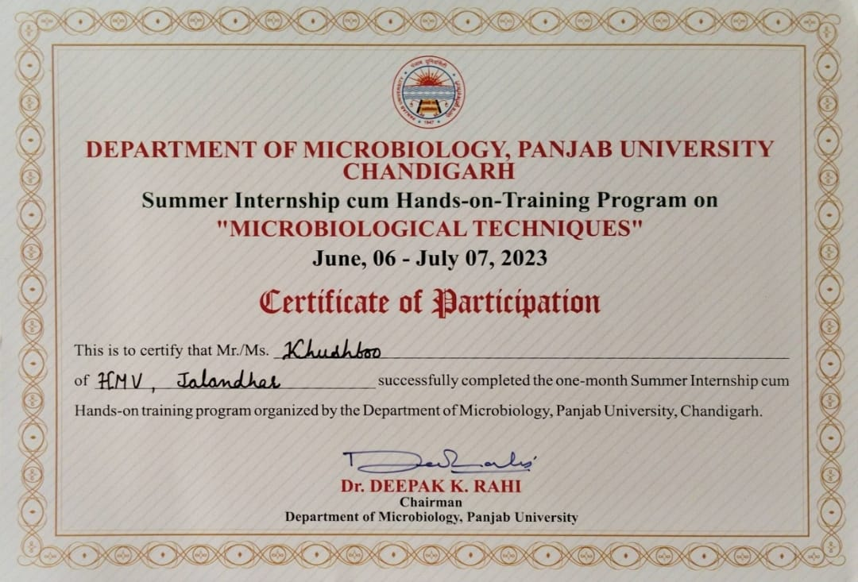

NAME- Kirandeep Kaur
ROLL NO.- 23102
E-MAIL- pannukiran2002@gmail.com
CONTACT- 70097-36982
INTERNSHIP INSTITUTE- Verka Milk Plant
DURATION- 14 Days
TOPIC- Milk Testing and Quality Assurance

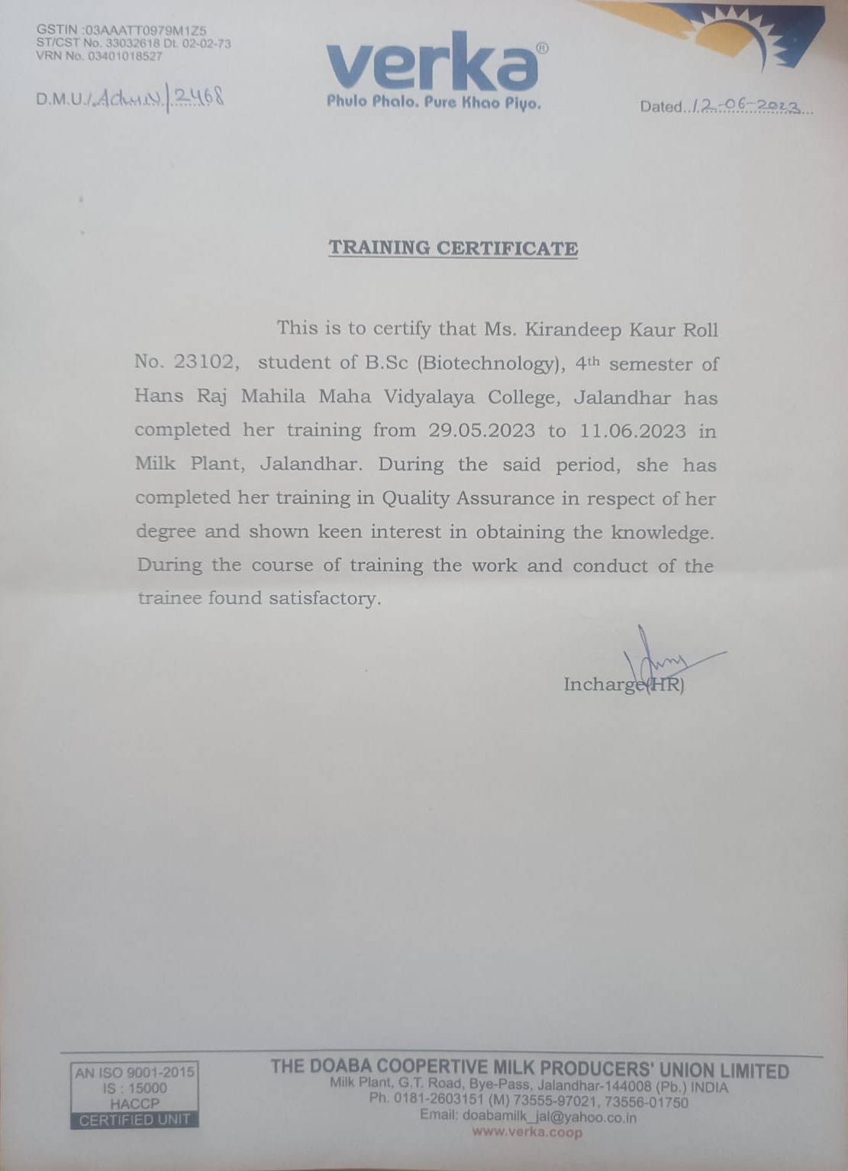

NAME- Antima
ROLL NO.- 23106
E-MAIL- antimaverma@gmail.com
CONTACT- 88728-56554
INTERNSHIP INSTITUTE- Verka Milk Plant
DURATION- 1 Month (30 May, 2023 to 26 June, 2023)
TOPIC- Milk Testing and Quality Assurance

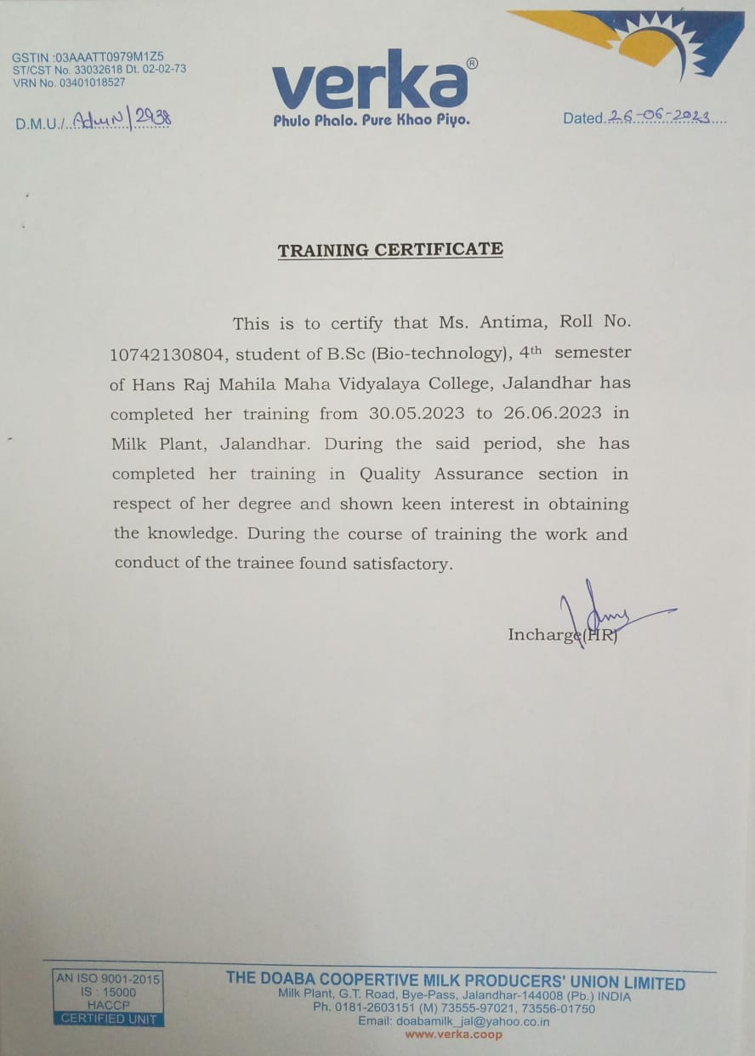

NAME- Sehajdeep Saini
ROLL NO.- 23108
E-MAIL- sehajdeep16saini@gmail.com
CONTACT- 70873-64667
INTERNSHIP INSTITUTE- Forest Research Institute, Dehradun, Uttarakhand
DURATION- 1 Month (1 June,2023 to 30 June, 2023)
TOPIC- Analysis of Genetic Diversity of Chukrasia tabularis using Molecular Biology Techniques

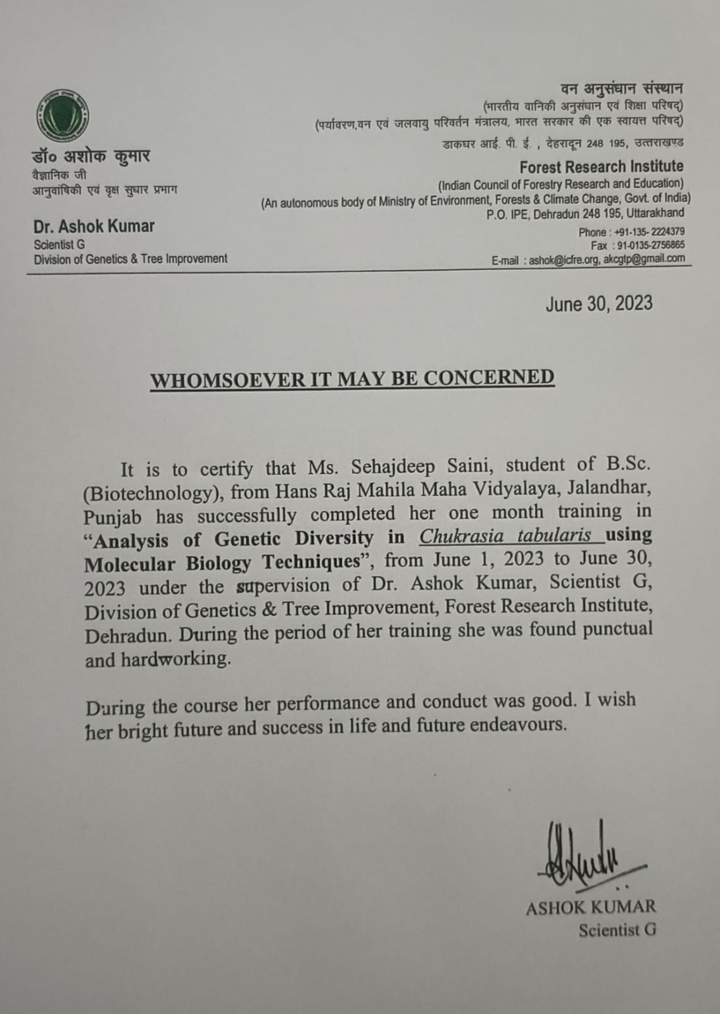

NAME- Manpreet Kaur
ROLL NO.- 23110
E-MAIL- mk7719726160@gmail.com
CONTACT- 77197-26160
INTERNSHIP INSTITUTE- Verka Milk Plant
DURATION- 14 Days (24 May, 2023 to 11 June, 2023)
TOPIC- Milk Testing and Quality Assurance

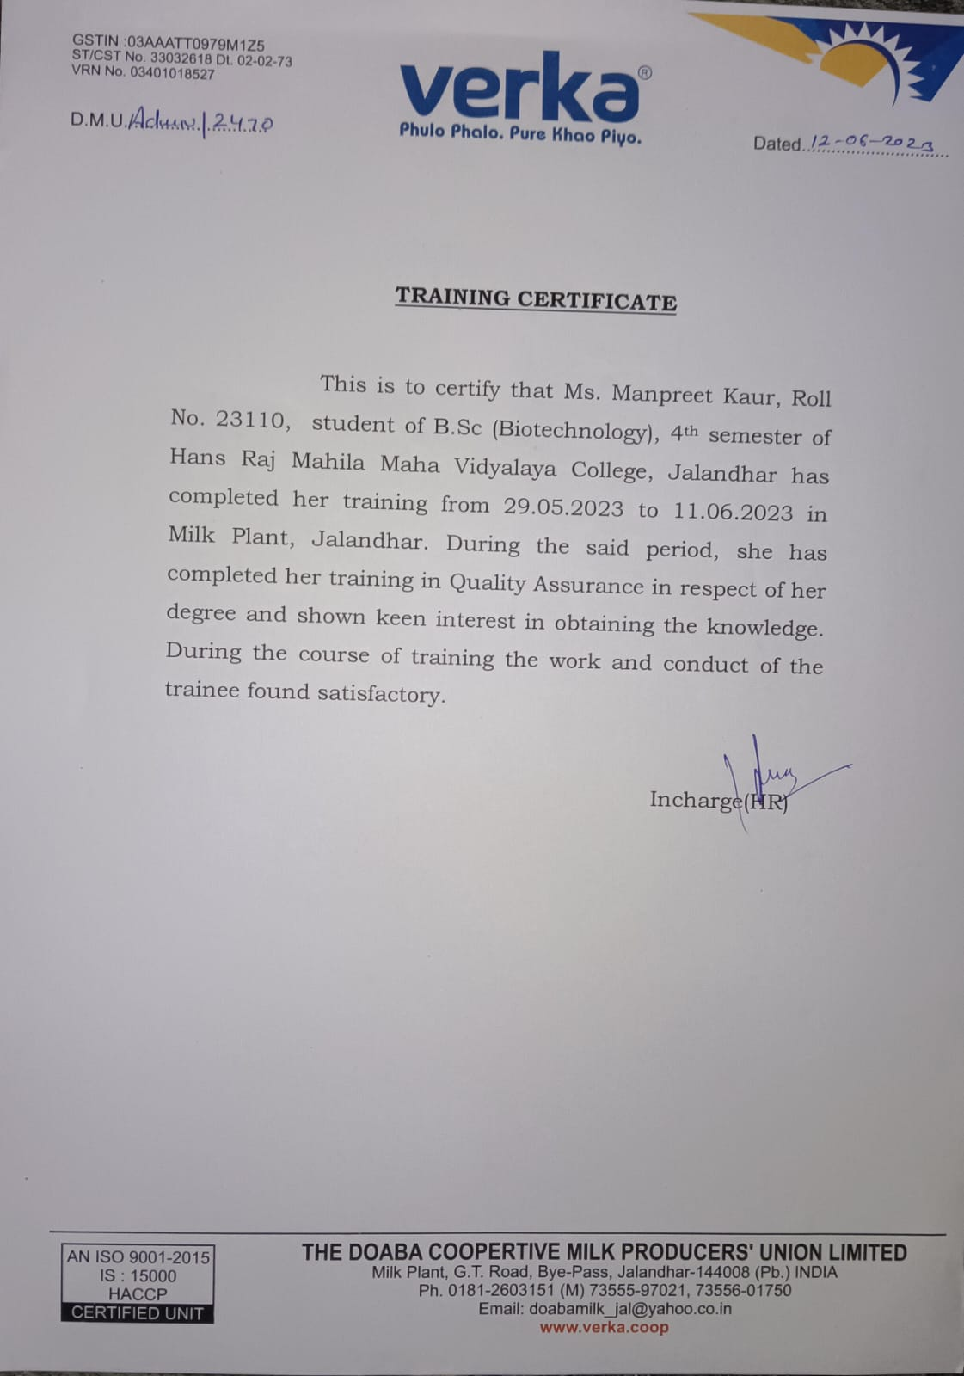

NAME- Palak Sharma
ROLL NO.- 23111
E-MAIL- palaksharma16014@gmail.com
CONTACT- 94785-76763
INTERNSHIP INSTITUTE- Forest Research Institute, Dehradun, Uttarakhand
DURATION- 1 Month (1 June, 2023 to 30 June, 2023)
TOPIC- Analysis of Genetic Diversity of Toona Ciliata using Molecular Biology Techniques

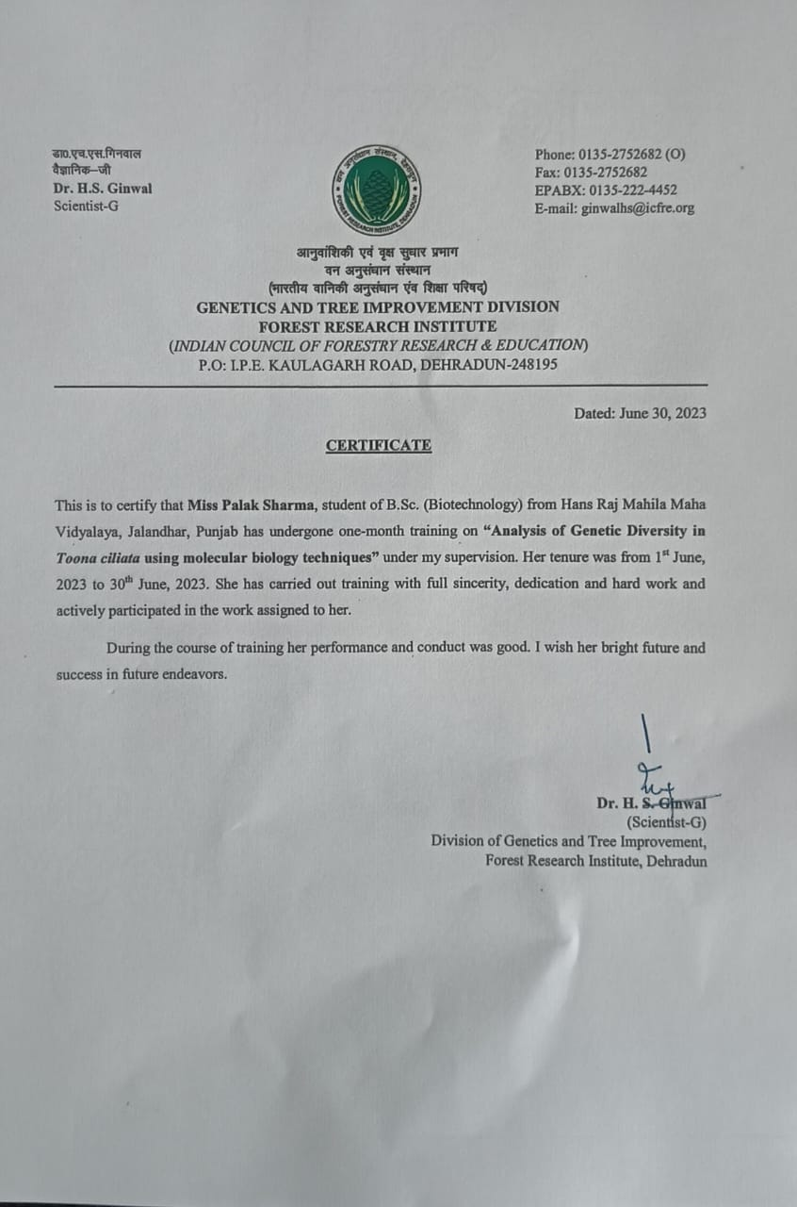

NAME- Shweta Kumari
ROLL NO.- 23113
E-MAIL- shwetakumari32007@gmail.com
CONTACT- 77173-72961
INTERNSHIP INSTITUTE- Rapture Biotechnology, Noida
DURATION- 1 Month (1 June, 2023 to 30 June, 2023)
TOPIC- Advanced Technique Modules

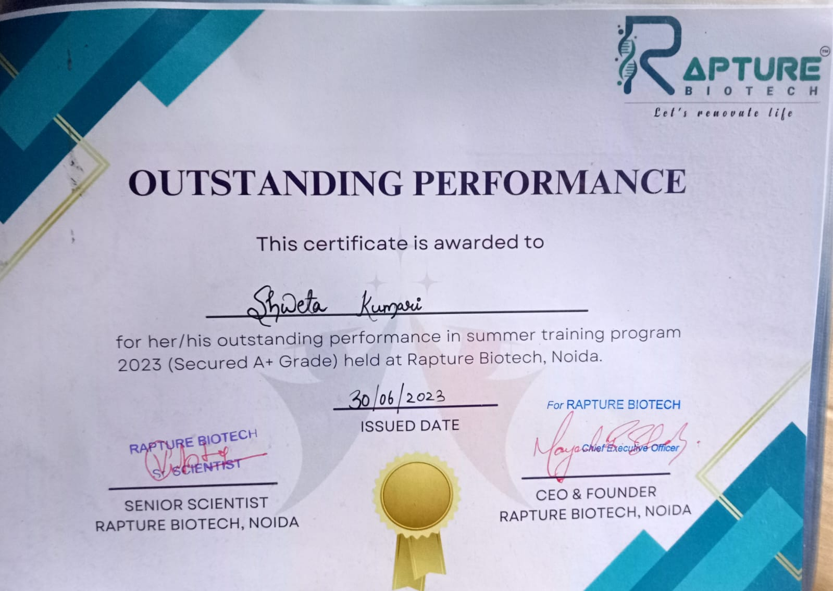

NAME- Komal Verma
ROLL NO.- 23115
E-MAIL- komalverma2301@gmail.com
CONTACT- 70098-36243
INTERNSHIP INSTITUTE- Verka Milk Plant
DURATION- 14 Days
TOPIC- Milk Testing and Quality Assurance

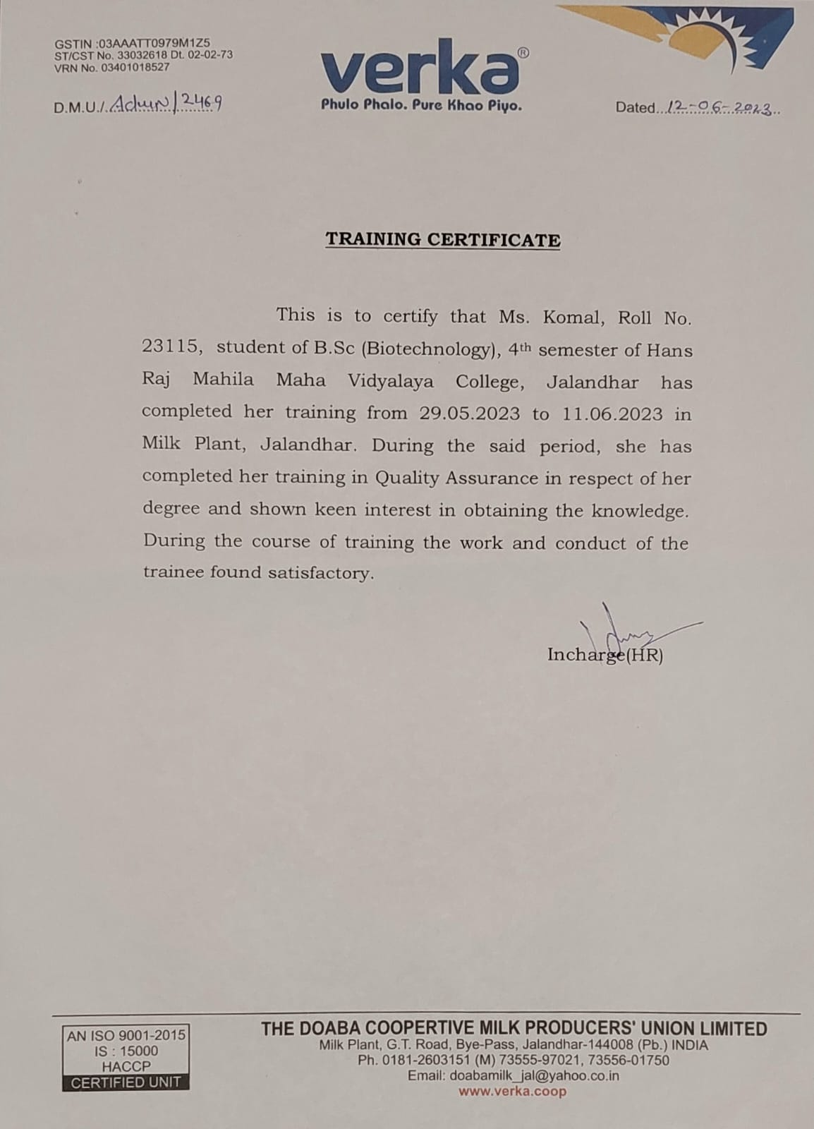

NAME- Komal Chowdhary
ROLL NO.- 23117
E-MAIL- komalchowdhary27@gmail.com
CONTACT- 94632-18705
INTERNSHIP INSTITUTE- Punjab University, Chandigarh
DURATION- 1 Month (6 June, 2023 to 7 July, 2023)
TOPIC- Microbiology Techniques

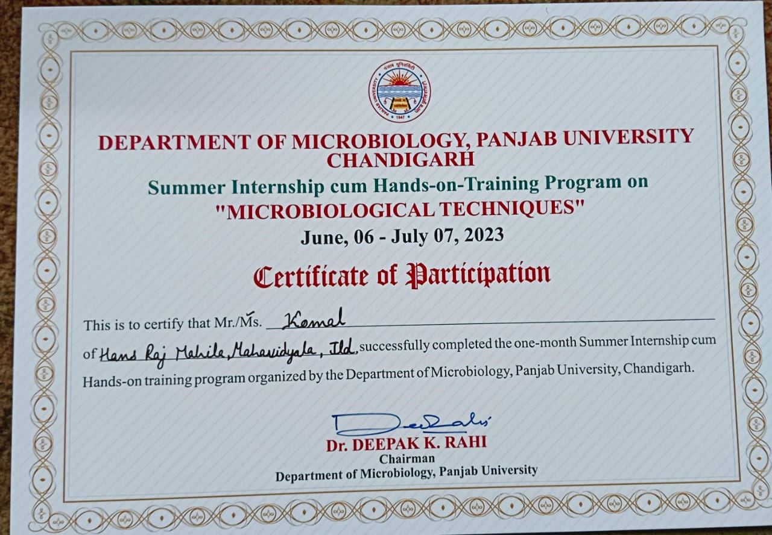

NAME- Navreen Kour
ROLL NO.- 23122
E-MAIL-
CONTACT- 91032-06645
INTERNSHIP INSTITUTE- Sher-e-Kashmir University of Agricultural Sciences and Technology
DURATION- 1 Month
TOPIC- Quantification of Zinc in Maize

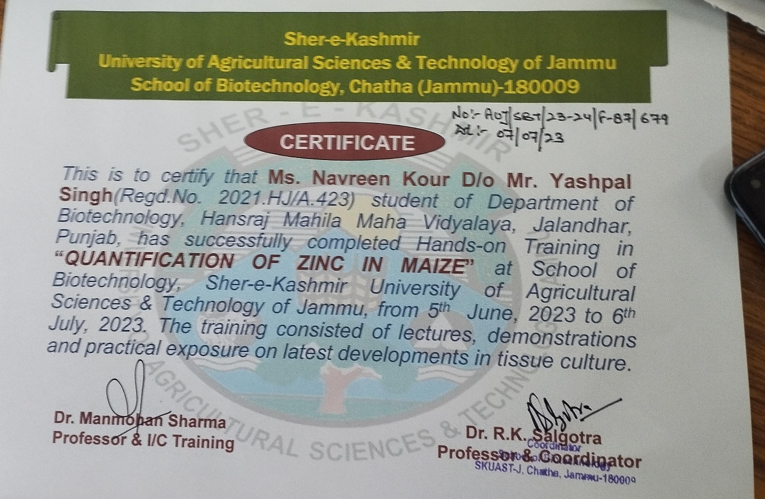

NAME- Nitya Bangroo
ROLL NO.- 23123
E-MAIL- bangroonitya@gmail.com
CONTACT- 94191-31919
INTERNSHIP INSTITUTE- Sher-e-Kashmir University of Agricultural Sciences and Technology
DURATION- 1 Month
TOPIC- Plant Tissue Culture Techniques

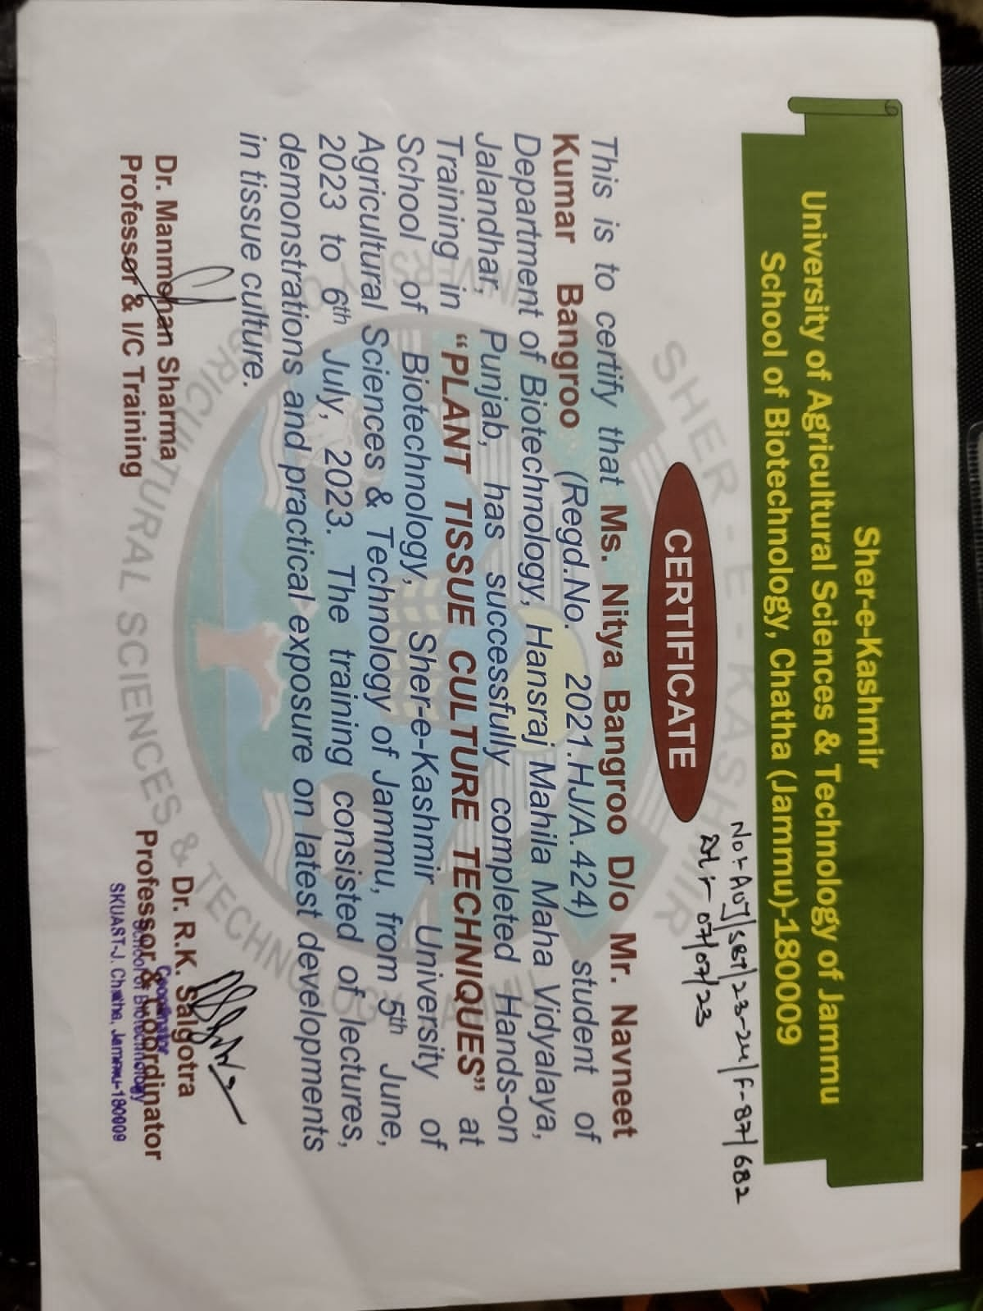

NAME- Roopali Sharma
ROLL NO.- 23124
E-MAIL- contactroopalisharma@gmail.com
CONTACT- 91031-13940
INTERNSHIP INSTITUTE- Sher-e-Kashmir University of Agricultural Sciences and Technology
DURATION- 1 Month
TOPIC- Quantification of Zinc in Maize

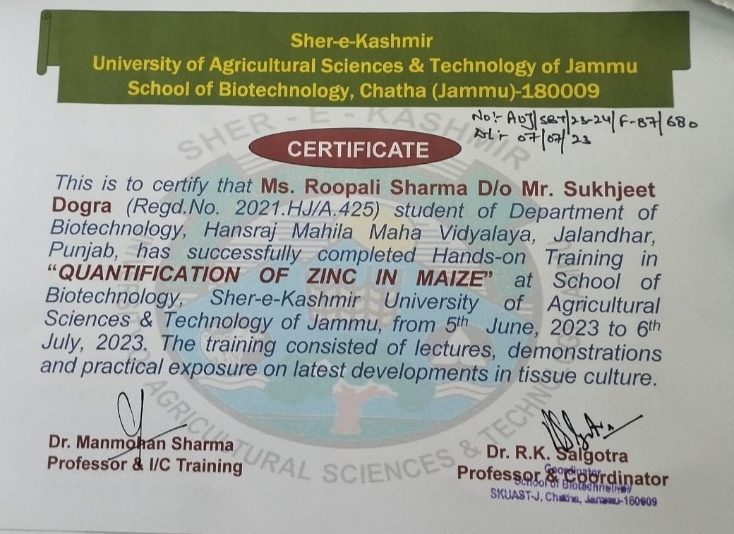

NAME- Deepanshi
ROLL NO.- 23125
E-MAIL- sharmadeepanshi417@gmail.com
CONTACT- 60058-28617
INTERNSHIP INSTITUTE- Sher-e-Kashmir University of Agricultural Sciences and Technology
DURATION- 1 Month
TOPIC- Plant Tissue Culture Techniques

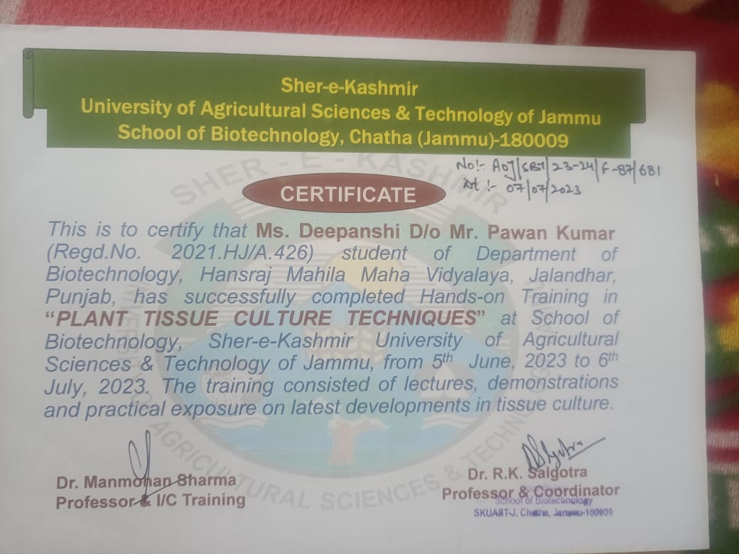

NAME- Arpana Sharma
ROLL NO.- 23126
E-MAIL- arpanasharma318@gmail.com
CONTACT- 60063-79541
INTERNSHIP INSTITUTE- Sher-e-Kashmir University of Agricultural Sciences and Technology
DURATION- 1 Month
TOPIC- Plant Tissue Culture Techniques

